

Student Name: Fred Mwangi
Admission Number: BSCCS/2024/74352
Course/Class:Computer Science
Unit Code: BIT4139
Unit Name: Ethical Hacking and Counter Measures
Lecturer Name:Michael Nyoro
Semester/Academic Year: Year 3 sem 2

Table of Content
Week 1:Set up Kali Linux 3
Step 1: Download VirtualBox 3
Step 2: Download Kali Linux VM Image 4
Step 3: Import Into VirtualBox 4
Step 3.1: Download 7-Zip 4
Step 3.2: Extracting the file 5
Step 3.3 : Opening VirtualBox 6
Step 3.4: Open Kali Linux 7
Week 1 Reflection : Setting up Kali Linux 7
Week 2: Penetration Testing Basics 8
Fig 2 : Showing penetration testing 8
Week 2 Reflection :Penetration Testing Basics 8
Week 3: Footprinting & Reconnaissance 9
Fig 3 : Found Google's IP: 172.217.170.174, Confirmed Google's IP: 172.217.170.174 9
Week 3 Reflection : Footprinting & Reconnaissance 9
Week 4: Scanning Networks 10
Fig 4 : Networks scanned 10
Week 4 Reflection : Scanning Networks 10

Week 1:Set up Kali Linux

Step 1: Download VirtualBox
Go to this link on your browser: virtualbox.org/wiki/Downloads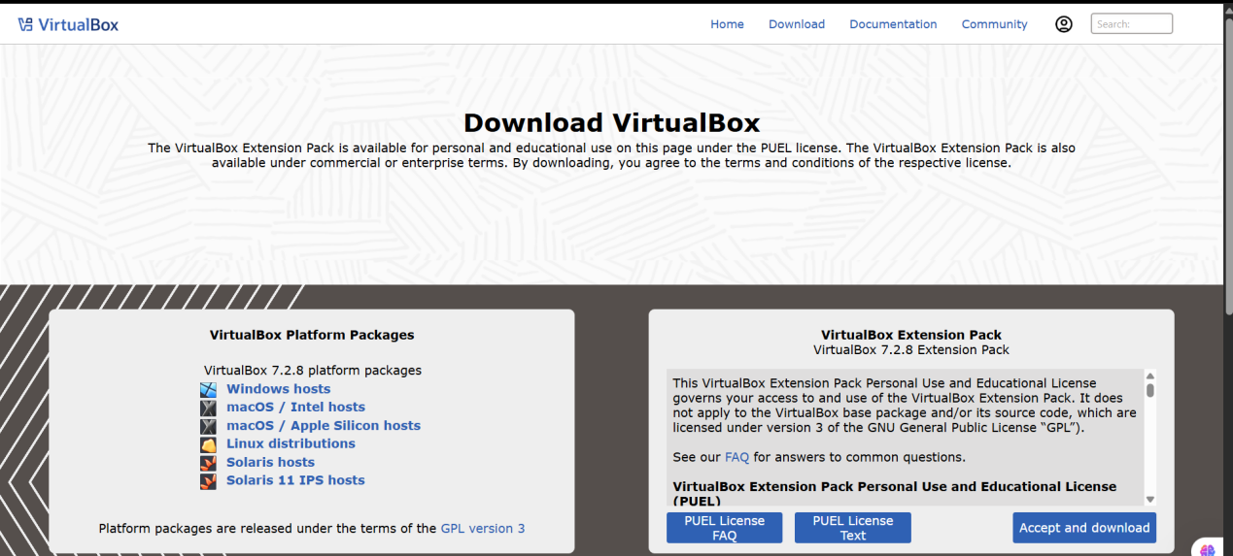
Fig 1.1 : Showing where to download virtualbox

Step 2: Download Kali Linux VM Image
While VirtualBox is open, go to your browser and open:kali.org/get-kali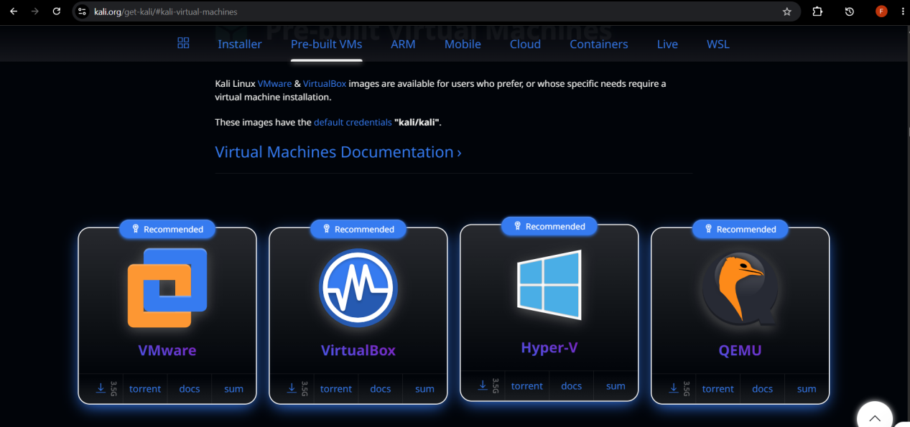
Fig 1.2 : Showing and downloading Kali Linux

Step 3: Import Into VirtualBox

Step 3.1: Download 7-Zip
The file is a Compressed Archive Folder (.7z) so we need to extract it first before importing into VirtualBox.
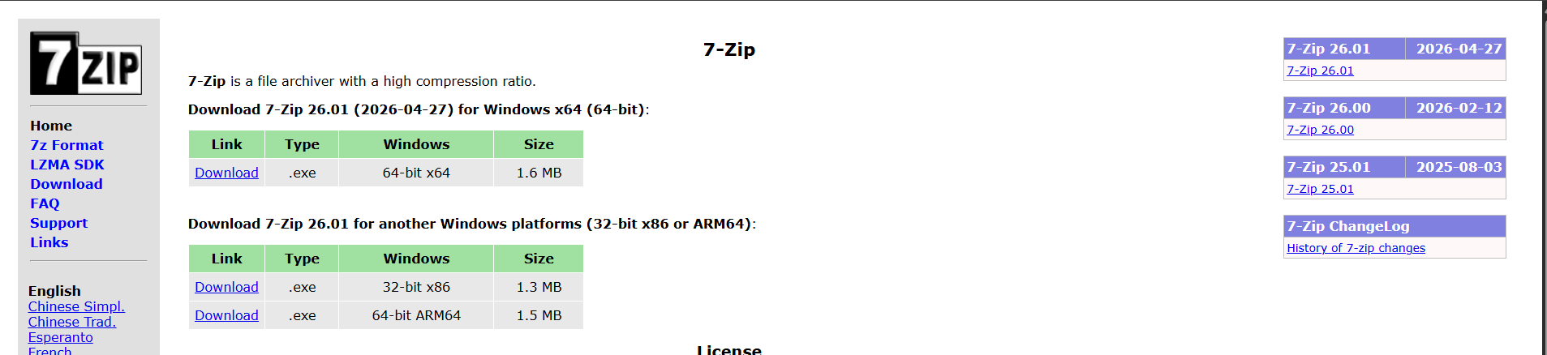

Step 3.2: Extracting the file
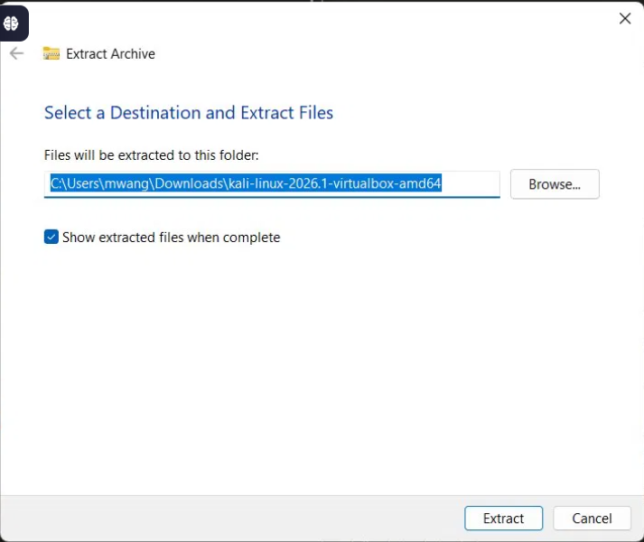
Fig 1.3: showing the Kali Linux file is extracted

Step 3.3 : Opening VirtualBox
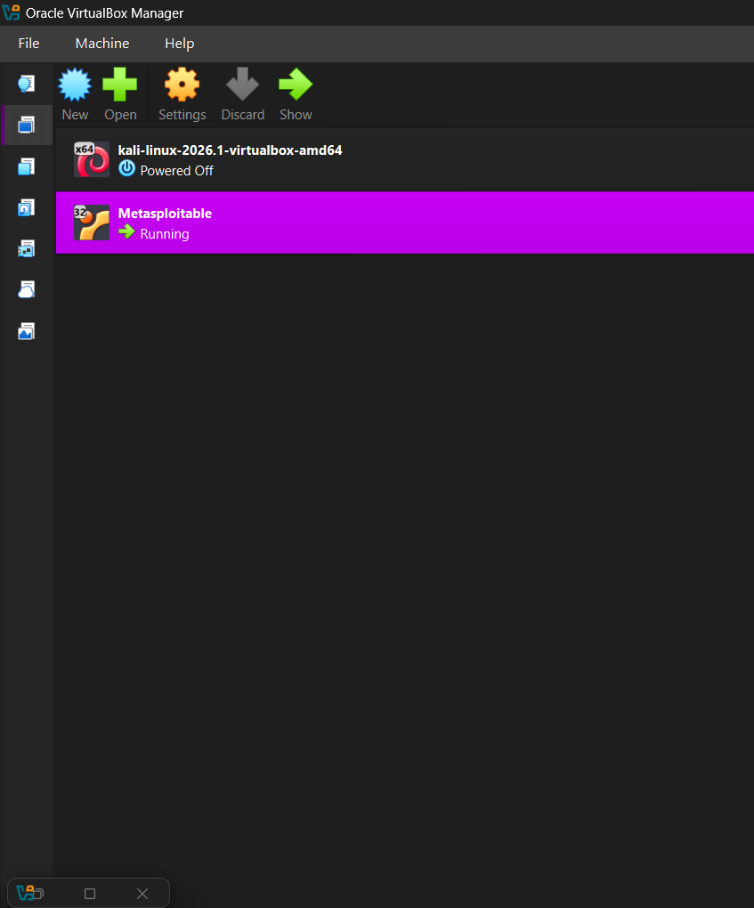
Fig 1.4 : Showing Kali Linux is Imported in VirtualBox
Step 3.4: Open Kali Linux 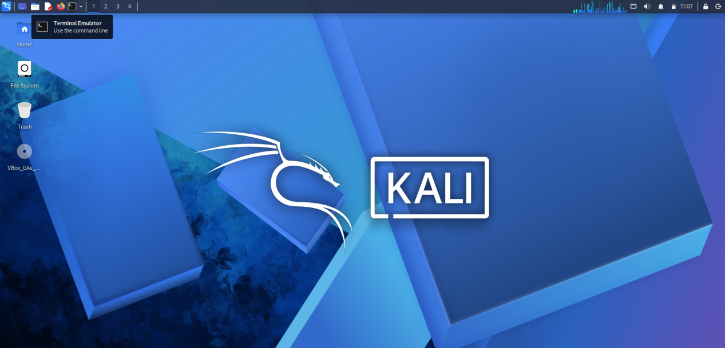
Fig 1.5 : Showing Kali Linux running

Week 1 Reflection : Setting up Kali Linux
During this week I set up Kali Linux on VirtualBox. One challenge I faced was storage limitations on my laptop as Kali requires significant disk space. I learned that VirtualBox is the most practical way to run Kali Linux without dual booting or replacing the existing operating system entirely. I also discovered that Kali Linux is preferred for ethical hacking because it comes preloaded with a wide range of security and penetration testing tools, making it an ideal environment for this unit.

Week 2: Penetration Testing Basics
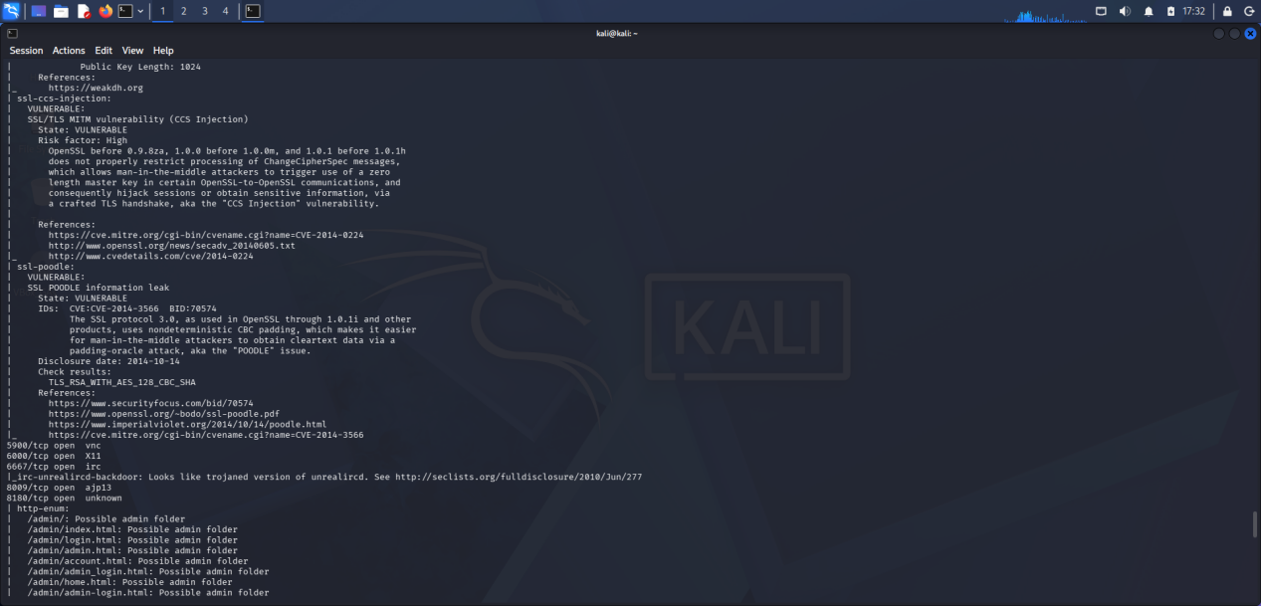

Fig 2 : Showing penetration testing

Week 2 Reflection :Penetration Testing Basics
I learned that ethical hacking is authorized and safe hacking done with permission to identify vulnerabilities before malicious attackers do. Unlike malicious hacking, ethical hacking follows a defined process and strict rules of engagement. I also learned how penetration testing reveals open ports and exposed services on a target system.

Week 3: Footprinting & Reconnaissance
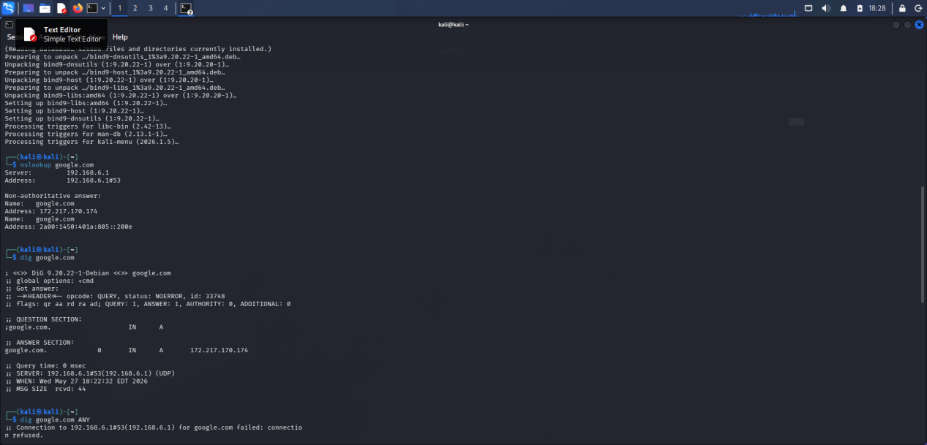

Fig 3 : Found Google's IP: 172.217.170.174, Confirmed Google's IP: 172.217.170.174

Week 3 Reflection : Footprinting & Reconnaissance
I learned that reconnaissance involves collecting information about a target before any attack simulation. I practiced finding a target's IP address, hostname and technologies running on the system. I discovered how much information a system exposes publicly without any authentication.

Week 4: Scanning Networks
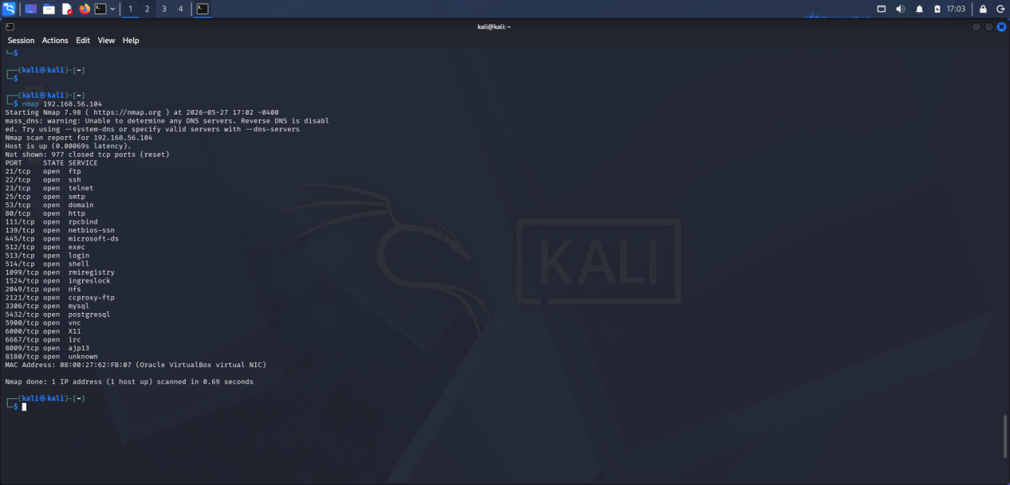

Fig 4 : Networks scanned

Week 4 Reflection : Scanning Networks
I performed network scanning using Nmap on a Metasploitable 2 target. I learned how to identify live hosts, open ports, running services and OS details. I found that Metasploitable 2 exposes many vulnerable services making it an ideal controlled environment for penetration testing practice.

